

**DEPARTMENT OF ORAL AND MAXILLOFACIAL SURGERY**

**TAGORE DENTAL COLLEGE AND HOSPITAL**

**MELAKOTTAIYUR POST, RATHINAMANGALAM**

**CHENNAI – 600127**

**PH: 044 – 3010 2222, EXTN: 228 / 230**

**EMAIL ID:** [maxfacs@tagoredch.in](mailto:maxfacs@tagoredch.in)

**PROF.M.MALA DR.C.J.VENKATAKRISHNAN**

**CHAIRPERSON PRINCIPAL**

**ORGANIZING COMMITTEE:**

**PROF.DR.S.JIMSON**

DR.B.LOKESH

DR.B.ANANDH

DR.BALAKRISHNA

DR.MEERAN SHARIF

DR.VINAY SUNDAR

DR.ISRAEL NATHANAEL

DR.JONES JAYABALAN

**ORGANIZER:**

Department of Oral & Maxillofacial Surgery

Tagore Dental College & Hospital

Date: **AUGUST 9TH 2021**

**LEARNING OUTCOME:**

To acquire detailed knowledge on Manuscript writing & Grant Writing.

**VENUE:** Conducted online through official **ZOOM** application**.**

**GUEST SPEAKERS:**

**1.Dr.Jeyshree.k**

Scientist –D

ICMR –NIE

**2.Dr.Rizwan S.A**

Scientist –D

ICMR-NIE

**TOPICS COVERED:**

1. Manuscript writing in Research methodology

2. Grant writing in Research methodology

The program started with the welcome note by the Organizing chairman, Prof.Dr.S.Jimson and a short introductory speech by Dr.Venkatakrishnan. The lecture session started by 10.15am. It was a detailed and very informative lecture on “manuscript writing”. A discussion session and question and answer session was followed by the lecture. The second lecture on “grant writing by Dr.Rizwan S.A started by 11.10 till 12pm .The program ended with the vote of thanks by Dr.B.Anandh.

**PROGRAM FEEDBACK:**

The program was attended by 71 participants. The program received a Excellent feedback from the participants.

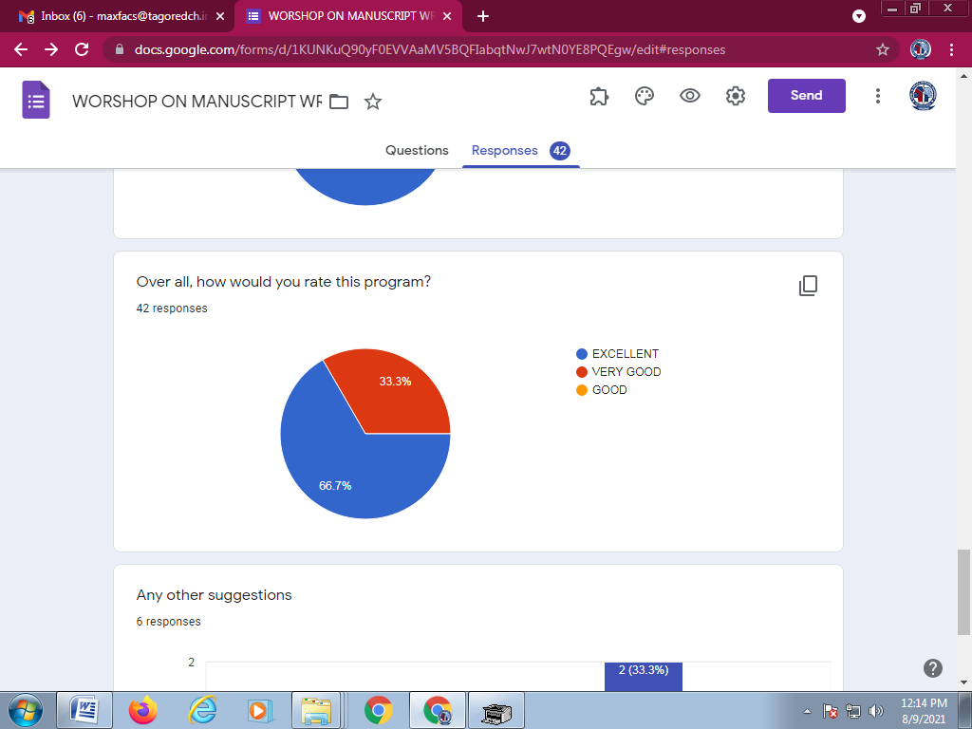

**PICTURES:**

