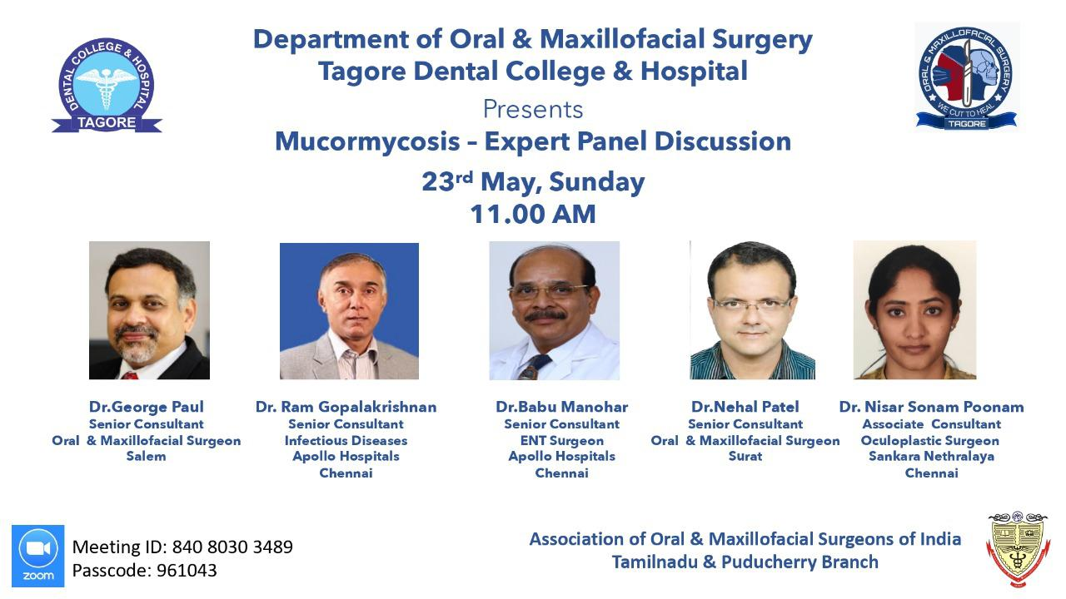

DEPARTMENT OF ORAL AND MAXILLOFACIAL SURGERY
TAGORE DENTAL COLLEGE AND HOSPITAL
MELAKOTTAIYUR POST, RATHINAMANGALAM
CHENNAI – 600127
PH: 044 – 3010 2222, EXTN: 228 / 230
EMAIL ID: maxfacs@tagoredch.in

PROF.M.MALA DR.VENKATAKRISHNAN
CHAIRPERSON PRINCIPAL

ORGANIZING COMMITTEE:
PROF.DR.S.JIMSON
DR.B.LOKESH
DR.B.ANANDH
DR.MEERAN SHARIF
DR.VINAY SUNDAR
DR.ISRAEL NATHANAEL
DR. JONES JAYABALAN

Title of the CDE Program: MUCORMYCOSIS EXPERT PANEL DISCUSSION (VIRTUAL)
Organizer: Department of Oral and Maxillofacial Surgery, Tagore Dental College & Hospital and Association of Oral and Maxillofacial Surgery Tamil Nadu and Pudhucherry Branch.
Date: 23th MAY 2021
Learning Outcome: To acquire detailed knowledge on Mucormycosis, clinical aspects, laboratory diagnosis, pathogenesis, prevalence treatment prognosis and current affiliation with the COVID-19 infection and the 2021 pandemic.
Venue: Conducted online through ZOOM application.

Guest Speakers:
- Dr. GEORGE PAUL
Senior Consultant
Oral and Maxillofacial Surgeon
Salem

- Dr.RAM GOPALAKRISHNAN
Senior Consultant
Infectious Diseases
Apollo Hospitals
Chennai

- Dr. BABU MANOHAR
Senior Consultant
ENT Surgeon
Apollo Hospitals
Chennai

- Dr. NEHAL PATEL
Senior Consultant
Oral and Maxillofacial Surgeon
Surat

- Dr. NISAR SONAM POONAM
Associate Consultant
Occuloplastic Surgeon
Sankara Nethralaya
Chennai

TOPICS COVERED:
- Introduction and basic understanding of Mucormycosis
- Pathogenesis of Mucormycosis
- Prevalence of Mucormycosis in Indian population
- Clinical manifestations of Mucormycosis in Indian population
- Relevance to present COVID scenario
- Case discussions by expert panelists
- Treatment options and surgical management

SCHEDULE:
Program | Time | Faculty
Welcome Address | 11.00am – 11.05am | Dr.S.Jimson
Introductory speech | 11.05am – 11.10am | Dr.C.J.Venkatakrishnan
Panel discussion | 11.10am – 1.30pm | Dr. George Paul  Dr.Ram Gopalakrishnan  Dr. Babu Manohar  Dr. Nehal Patel  Dr.Nisar Sonam Poonam
- Mucormycosis
- Introduction
- Pathogenesis
- Prevalence
- Clinical manifestations
- Relevance to present COVID scenario
- Case discussions
- Treatment options and surgical management
- Query session
VOTE OF THANKS | 1.30pm – 1.45pm | Dr.S.Jimson

Report:
The “MUCORMYCOSIS EXPERT PANEL DISCUSSION” started at 11.00am.
Welcome address was given by Prof.Dr.S.Jimson. The Principal Prof.Dr.C.J.VenkataKrishnan addressed the gathering and gave an insight into the importance of this panel discussion for the present pandemic scenario.
The Discussion started by 11.10 am, moderated by Dr.Suresh Kumar .The discussion consisted of expert panelists who shared their knowledge on Mucormycosis and its fatal bridge with the present Pandemic.
A Detailed explanation on the disease was given by Dr.Babu Manohar followed by Dr.Nehal Patel who talked on the pathogenesis of the disease . Dr. George Paul shared the dental aspects and intra oral manifestations of the disase and also questioned on the pathogenesis and the extra oral involvement of the disease ,to the other expert panelists.Case presentations was done by Dr. Nehal Patel and Dr.Nisar Sonam Poonam .The presentation was later passed on to by Dr.Ram Gopalakrishnan who talked on the recommended medication , respective dosages and existing protocols .later , a short conclusive discussion was done by the panelists followed by questioning session for the participants .The program concluded with the vote of thanks by Dr.S.Jimson.
The program was attended by more than 500 members in the ZOOM app platform, and 327 members in the LIVE – YOUTUBE Interface. It was highly beneficial for more 800 participants inclusive of undergraduates, post graduates and faculties from various medical and dental disciplines. The program received a good feedback from the participants.

PROGRAM FEEDBACK:
A feedback form was given at the end of the discussion for the participants. The participants were asked to assign a score for the discussion session and resultant was calculated.

PARTICIPANTS SCORE | PERCENTAGE
5 | 60%
4 | 20%
3 | 10%
2 | 9%
1 | 1%

The Program received a very optimistic feedback. The score sheet for the program was analyzed and 90 percentage of the majority of the participants have found the program exceedingly informative and to the point.

INVITATION CARD:

PICTURES:

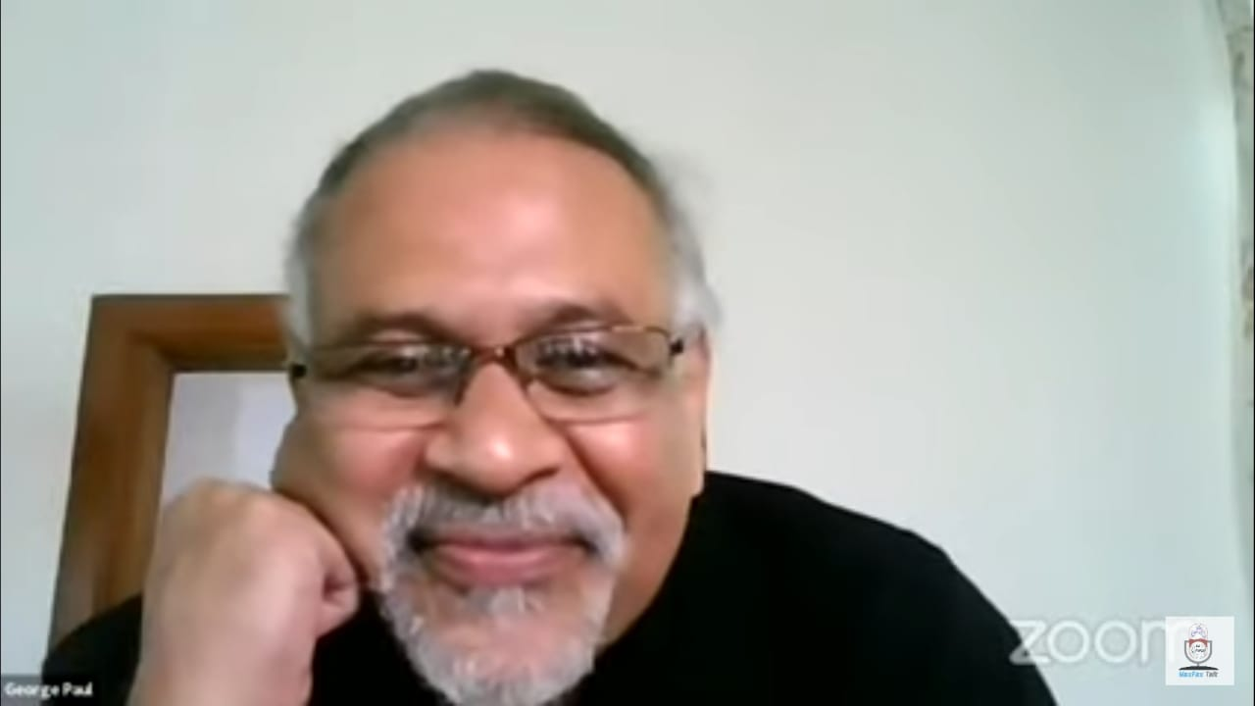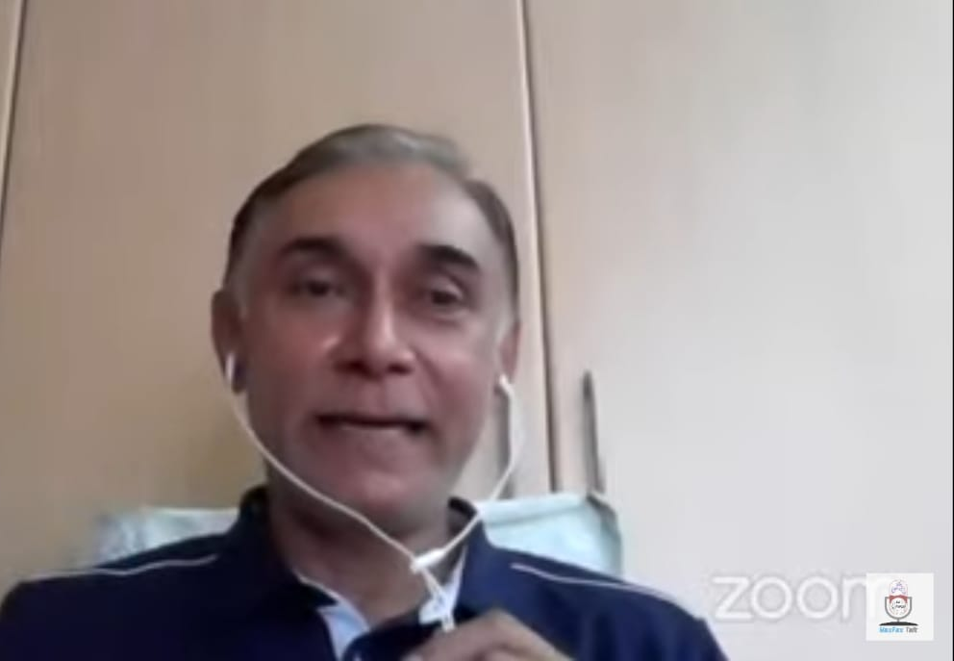

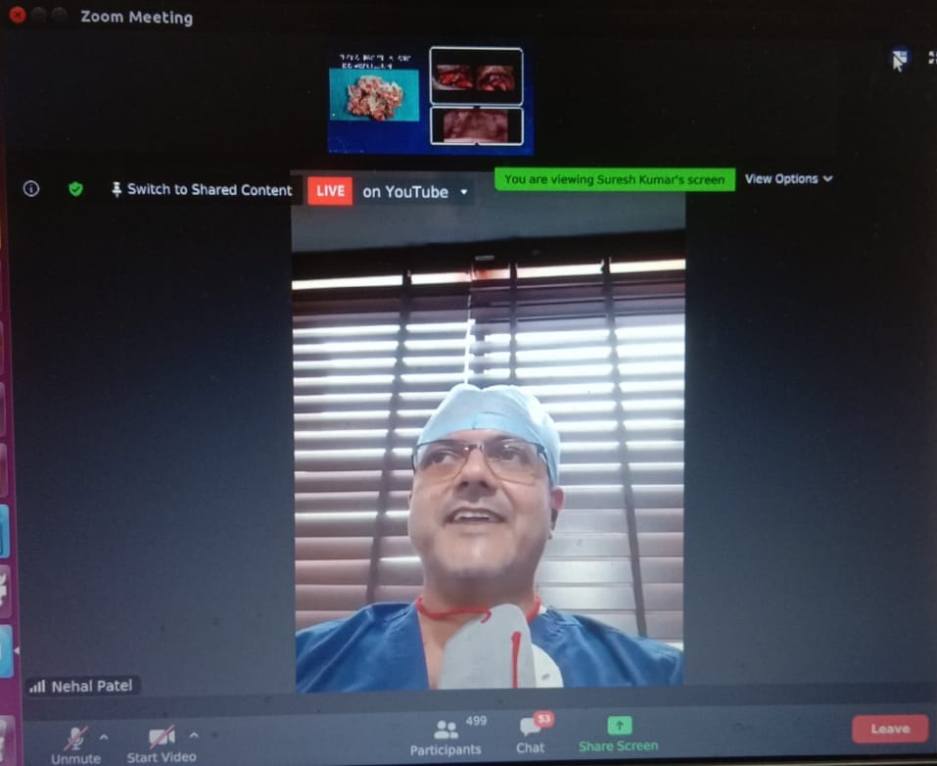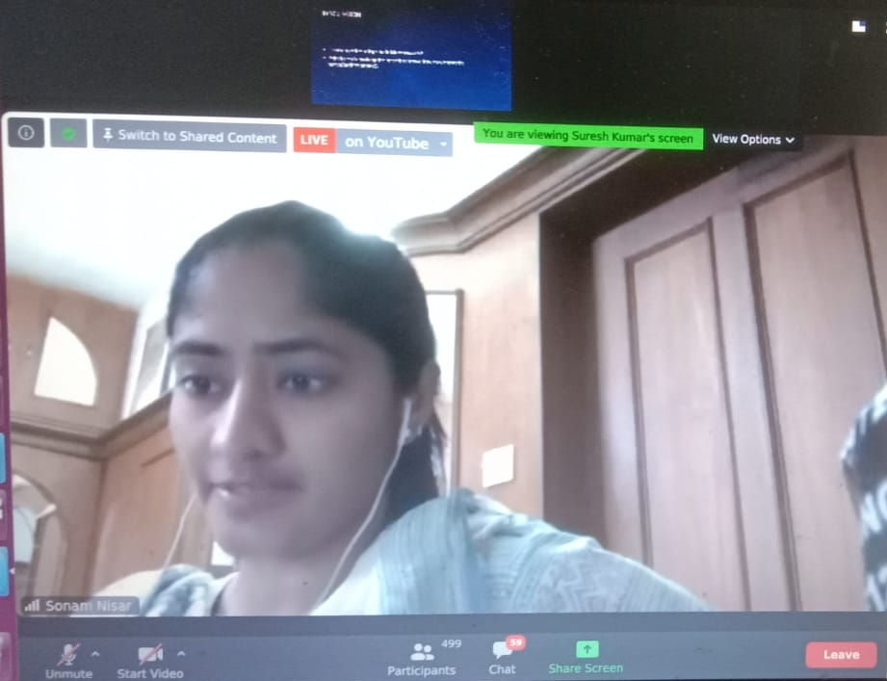

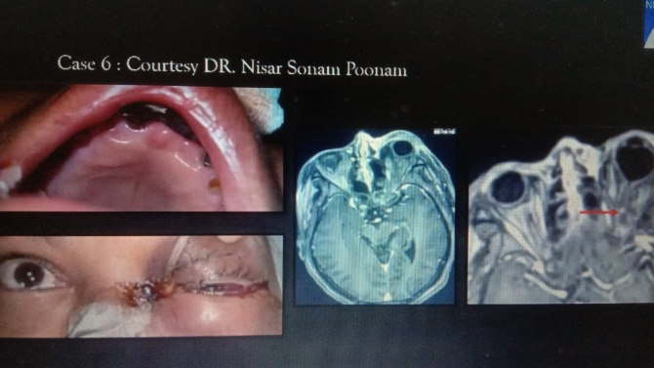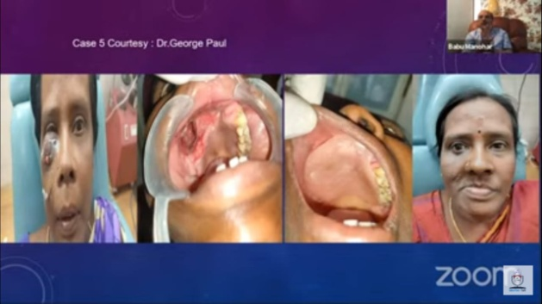
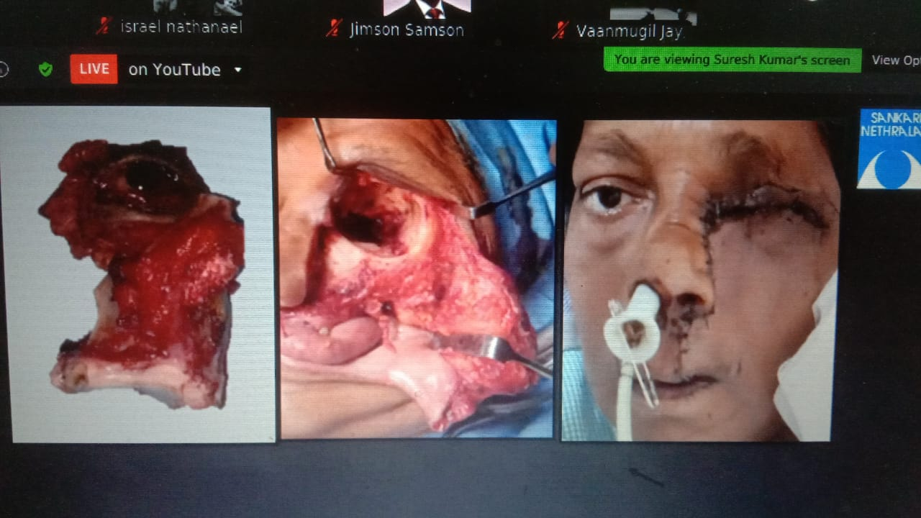

PARTICIPANTS LIST:

Dr.K.Raveendharan | Avinash.G | Sumaiya Basheer |  |  |  | Sivaranjani s
Dr.S.C.Ahila | karthik Raj | Dr Yasasvini Jambulingam |  |  |  | Janani
Dr Shruti Khatana | Dr Harshhan D | Akhileshwaran. R |  |  |  | Sethu Sree. G
Kalpita Deb Barman | Dr Drishti Shah | RENUKA AJAY AVINASE |  |  |  | Rakshna Nedumaran
N Snigdha Praneetha | Dr. Sreejee G | Dr. Shivangini Nayak |  |  |  |  | Dr.Syed Vikharuddin
Pavithra Sadasivam | Blessy monisha R | Dr. PramudhaShree Mourya G V |  |  |  |  | Dr Sanket Sachidanand Nayak
Dr. Manasi Bavaskar | SUHASINI | vadupu meghana |  |  |  |  | Ragavi.R
Dr.Asok kumar RS | Kshitij Pradhan | Dr. Prathiba Senthilkumar |  |  |  |  | DR. MRINALINI SINGH
Sanjay Karthik K | RUNJALA SUSAN DAISY CRIS | Vineela Bonthu |  |  |  |  | ANTONY THOMAS RUBAN J
Shamyugta.C | Dr. Vinanthi P.V | Dr SYEDA KANIZ UMUL BANEEN |  |  |  |  | N.S.YAZHINI
MEHUL BAGMAR R | Kirthieka.S | Dr. Manju Kurakar |  |  |  |  | Malar Magal A
Dr. ARITRA ROY | DR. CHANDRALEKHA | Nisha Daphne .R |  |  |  |  | Vaibhav Gorakshanath Momale
Dr. ALIZA RIZVI | Niveditha N | Dr G Vasupradha |  |  |  |  | M.SHRIKAVI
MITTAPALLY SNEHAXY | Dr.Gopika M G | Dr. Arya V M |  |  |  |  | Dr. Apoorva Mowar
havilahdeepthi | Dr.Balaji.B | Aishwarya. S |  |  |  |  | Dr Thomas Zachariah
KHANYA A | Rohit Goyal | V Bakya Lakshmi |  |  |  |  | AKSHAYA.N
Krishanga srivastava | Dr.Sasikumar | Dr Deepa Ponnaiyan |  |  |  |  | Jayapal Vaanmugil
Dr.Juhi Talreja | DHANALAKSHMI P | SHRADHA MALIK |  |  |  |  | Dr. Nikita Bathija
Dr Anum Rana | M.Nivetha | Dr Sahnazul Hoque Talukdar |  |  |  |  | Seelam Madhuri
Dr. Sugam neema | Kalyani. P | Dr. Sonal Mishra |  |  |  |  | A.M.Roshini
Rodoshi Roy | Dr. Naseer Mohammad | GOLLA GOWTHAM |  |  |  |  | Avinash Moorthi. K
Dr TANMAY MANDAL | Dr.DRISHTI BHATT | Jones Jayabalan |  |  |  |  | Asha J
Vikas Gunishetty | Dr Arunima Raut | N.R.Pooja |  |  |  |  | DR.SUPRAJA R
Jananee Bharkavi N | Hanisha Selvan | Dr.Amirthaa Priyadharscini R |  |  |  |  | Dr Swetha
SHARMILA. E | G.Elakiya | Bhagyasree Nair |  |  |  |  | Preethi
Dr R Kannan | Deepika. R | AKKSHAYA S |  |  |  |  | Benita florance
Dr Anuradha Dalal | Harsha Vardhan P | Dr. Kanishk Srivastava |  |  |  |  | Surya N G
Dr PARTH SUTHAR | Dr. Nishant Kumar | Gogula Sree roopa |  |  |  |  | Dr ARATHI K
Bhargavi T | Poorani.V | Harshitha Balaji |  |  |  |  | Pramod Bhalerao
Ezhil Bharathi I | J. FIONA | Dr Yajas Kumar |  |  |  |  | A. BHARGAVI
P.KAVITHA | Dr. Jothy Arvind A.V. | V.Akash |  |  |  |  | Dhamini. P. M.
Nithyashri P | Dr. Ishita Singhal | NIVETHITHA M |  |  |  |  | Dr. Shreya Rani
DR SACHIN KUMAR | Ravi Gupta | G.PREETHA |  |  |  |  | Aishwarya Ravi
Shreeyan Nayar M.N. | N Deva Kumar | Bharany Malavika.j |  |  |  |  | Dinakar R
Vora Aditya Nehalkumar | DR. JANHAVI MODI | Dr. shakshi ganeriwal |  |  |  |  | Dr. Nandita Das
Dr Vidya Sagar Badugu | G Rakesh | AJITH G |  |  |  |  | Tamma prathyusha reddy
Dr Suresh G | RENU JINDAL | Dr.ABDULHASEEB QUADRI |  |  |  |  | Goutam P
Dr. Aakansha Bhardwaj | Dr. A. Ramisz Rahman | Abinaya.P.T |  |  |  |  | KEETHANA R
Dr.S.Shabana Fathima | DR KAMINI DADSENA | Kunal Debnath |  |  |  |  | Mohan Raj D
Keerthi P | Deepika Purushothaman | Dr Vandana Shenoy K |  |  |  |  | Sudarshan
DR.N.BALAJI | Dr. Isha sharma | G.R.GOWTHAMI |  |  |  |  | Dr. Thomson Mariadasan Dcruz
Dr K Thanvir Mohamed Niazi | Rajeswari R | Yoganathan E |  |  |  |  | Jasnoor Singh Sidhu
sridevi sivaramakrishnan | DR SHALINI | M.VINITH KUMAR |  |  |  |  | Dr Akshata Kotharkar
Dr. Nitin B. Jadhav | Mohit Bagmar R | E.SundaraKannan |  |  |  |  | Dr K ANANT NAG
Dr B DINAKAR REDDY | Felcy A | Naresh |  |  |  |  | Nirmal kumar.R
SARAH.E | Dr. Sushobhan Das |  | G Shabitha
Iswarya K | Puvana |  | Dr.Shweta Wadekar |  |  |  |  | S.NAVAPRIYA
Shaik Mohamed Ansar | Srijanani S |  |  | Dr. Adhithya B |  |  |  |  | AKSHAYA SUBHASHINEE
Vijay | Moniesha kumar |  |  | Yamini Kanipakam |  |  |  |  | Hemavathy karthick
S Harivignesh | M.Geethanjali |  |  | Monisha.N.C |  |  |  |  | T.Tanish
Dr. V.Mageswaran, M.D.S., | Dr.Sanjeev Tomar |  |  | Latha P Rao |  |  |  |  | Soora sivashanmugam Sudharsan
GAYATHRI V A M | Dr C Suresh |  |  | Kiruthika B |  |  |  |  | V. Stavan
Dr.sangavi B | Surya Udai Singh |  |  | Kabilan |  |  |  |  | Dr Sarah Deepika Stephen
Dr Akshay | Dr. S.Amulya Sudha |  |  | Dr.K.Raveendharan |  |  |  |  | Aravind christo.A
Dr Priyadarshini N A | Dr Shobha E.S |  |  | Malarvizhi.G |  |  |  |  | Abinaya M
Dr.Seetha Sadhasivam | Dr Shanmuga Sundaram D |  |  | Dr.Bino Bright |  |  |  |  | Dr.Srinath
A. Puvitha | Dr. Harshita Vig |  |  | Dr.C.Gayathri |  |  |  |  | I SHIYAM SUNDHAR
S.Sivaranjani | Dr.S Vijaykumar Jain |  |  | Dr E Lakshmi Priya |  |  |  |  | Ashwini
aditi ohri | ARRVINTHAN.SU |  |  | Pavithra Sarda.K |  |  |  |  | Jeyamitha
Ambuj Aggarwal | Dr Niveditha Thampan |  |  | Mariam S |  |  |  |  | Sapna Deepa Prakash Somani
DR.K.SENTHIL KUMAR | Dr Ramesh Kumar mamatha |  |  | AARTHI R |  |  |  |  | Ajaikumar. T
PANDIYARAJAN P | SURYA RAJEEV NAIR |  |  | Dr.Dhanyaraj |  |  |  |  | S. Ajithkumar
VETHIKA.K | Dr. Malini Murali |  |  | S.Anitha Roselin |  |  |  |  | Dr.Sudarsan Sen , MaxilloFacial Surgeon
Anjali Vijayan | Nilopher Sherin |  |  | DR.PAVITHRAN.A |  |  |  |  | Sanjanaa Kapoor
Moushmi K | Dr.Saurabh Mallick |  |  | Shaheen Begum |  |  |  |  | Rahul Murugan
Aarudra devi JG | Dr.NEHA NAIR |  |  | Suthamancharri |  |  |  |  | Dr.Priyanka Jain
Venkateshpraveen M | N.kushall raj |  |  | SIVAPRASAATH S |  |  |  |  | Dr. Danveera Raut Dessai
R.Ragha Priya | Varsha J Lekshmi |  |  | Dr. Aravindh Radhakrishnan (MBBS, DNB, MCh) |  |  |  |  | S.NANDHINI
PARINITHA JAYARAJ | GokulaPriya. R |  |  | Kanimozhi |  |  |  |  | R.Moin khan
Dr.G.S.ASOKAN | Prithivirajan G |  |  | P.Aarthi |  |  |  |  | Lakshmi Rathan A C
Swetha.S | Ayesha Moin |  |  | V.Rithvina |  |  |  |  | Priyanka
Akula Swetha | Dr.Shishir Lanjewar |  |  | Meenakshi Pandey |  |  |  |  | S. Akshal Christy
Alejandra Giselle Juárez Rebollar | Marshal |  |  | Swathi Shammi |  |  |  |  | Dr S Balagopal
Dr.Ashwini Babasaheb Bhojane | Smriti Kumari |  |  | DURGALAKSHMI M |  |  |  |  | Ramya.A
Dr. C. Joice Vinodine | Dr. CL Krithika |  |  | AJITHKUMAR NAGAMALAI |  |  |  |  | Dr.Swapna Mahale
Dr P Mowniga | N.RAKSHANASAISREE |  |  | Bhavan Kumar.V |  |  |  |  | Dr. Ruchira Shukla
T.Sumaiya Fathima | J H Preetha |  |  | Dr.SREE LAKSHMI.S |  |  |  |  | Nivetha Manoharan
Shanmugapriya | Subiksha Ravi |  |  | B.Samantha |  |  |  |  | Gayathri.G.V
Swetha. V | G. A. Kiruthika |  |  | JANANI T |  |  |  |  | Joshmitha
Shalini. S | A.Kalki Priya |  |  | GEETANJALI ARORA |  |  |  |  | RAJAPRIYA N M
Dr.M.Rohith Kumar | Dr M JYOTHSANA |  |  | Jebaselvi.P |  |  |  |  | Aaron Francis Savio Rufin Gomes
P.AKSHAYA PRIYA | Dr. Shruthi R |  |  | B.Subash |  |  |  |  | Paarthieban TB
R DEVADHARSHINI | Dr.Ashika Aman |  |  | Aishwarya. K |  |  |  |  | Meru s
Sameena Ali ahmed Shaikh | Kanimozhiy Senguttuvan |  |  | Kamil Haneef |  |  |  |  | Dr Geetha Kamath
Nafeesa.A | Dr Divyaraj |  |  | Shara Trisha.P |  |  |  |  | P. Sangavi
KIRUTHIKA.S | J. Naga Jyothi |  |  | Karthikeyan A |  |  |  |  | Shaik Abdul Riyaz
Aishwaraya Gupta | J.s.karunyamercy |  |  | Arun Prakash |  |  |  |  | Suvadip Bhattacharjee
Dr.Varsha Rani | Ravishankar P.L |  |  | Priya.S |  |  |  |  | Nivedha N
Yeshaswini Thelekkat | Reji Abraham |  |  | Dr. Arungani NS |  |  |  |  | Karthik k
Syed Sajjad Ahamed.P | s.kiruthika |  |  | Dr.Elamathi R R |  |  |  |  | Tharunkumar
E.Raj Shree | Dr Bela Dave |  |  | KANMANI R |  |  |  |  | Logesh.R
Ms. Fida Mansha OT | Prasanth.G |  |  | C.VARSHINI |  |  |  |  | M. MANIKANDAN
Ravin.R | Dr Bela Dave |  |  | Manasa |  |  |  |  | N. Sheetal Ritu Mancy
HEMAVATHY | Prasanth.G |  |  |  |  |  |  |  |  | R.Sasi kumar
Roshan R. Rughwani
DR.iSRAEL
U.Yamini

